MEMORANDUM
PROCUREMENT MANAGEMENT UNIT

P

To : THE PROCUREMENT MANAGEMENT UNIT
FROM : EVALUATION COMMITTEE CHAIRPERSON
DATE : 23 OCTOBER 2025
REF: PROCUREMENT FOR JOB EVALUATION
The Administration Department would like to procure job evaluation services.
Fourteen (14) bidders submitted their bids and the evaluation process is evaluated as shown below:
PRELIMINARY EVALUATION
COMMENTS
A preliminary evaluation was done and all bidders that did not submit the required documentation were disqualified. Thereafter a technical evaluation was done to the bidders that proceeded.
TECHNICAL EVALUATION
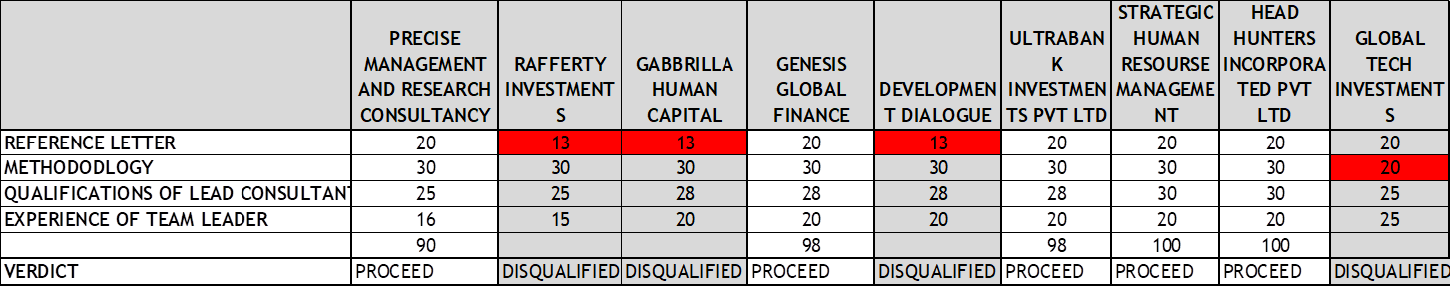
COMMENTS
A technical evaluation was done as shown above and organisations that failed to meet a minimum score of 70 where disqualified.
Of the nine (9) suppliers who proceeded to technical evaluation three (3) were disqualified that Rafferty Investments, Gabbrilla Human Capital and Global Tech Investments and Development Dialogue were disqualified for failure to submit the required minimum of three reference letters and failure to meet the methodology respectively

