Telephone: +263-73–2525/26  Fax: +263-73-3048  Email: gordc@mweb.co.zw | 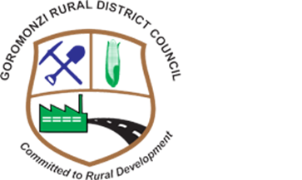 | Reference:  GOROMONZI RURAL DISTRICT  COUNCIL  Chief Executive Officer  P.O. Box 95  RUWA  All correspondences to be addressed to the Chief Executive Officer

EVALUATION SUMMARY PROCUREMENT OF ROOFING MATERIAL

NAME OF BIDDER | ELIGIBLITY | TECHNICAL | TOTAL BID PRICE | RANKING
Adlar Trading | NOT COMPLIANT
Lendel Trading | NOT COMPLIANT
Michmat Investments (Private) Limited | COMPLIANT | COMPLIANT | 37 864.13 | 1

